❗❗IMPORTANT REMINDER❗❗
Please make sure to take note of all services, functions, objects and databases you create.

LAMBDA
RESTRICTED TO:
Region: ap-southeast-1(Singapore)
Function name should start with: awsnodetraining

(For lab exercises thru console)
Select Author from scratch
Fill out the Basic Information
Function name: awsnodetraining*
Runtime: Node.js xx.x
Architecture: x86_64

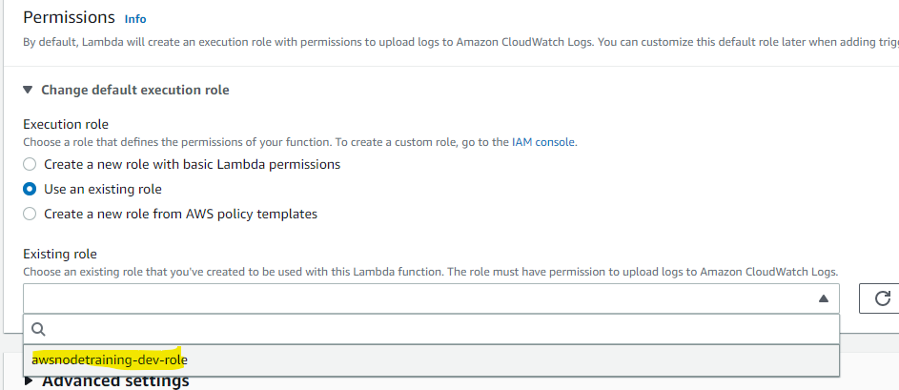

Click Create Function

DynamoDB
RESTRICTED TO
Region: ap-southeast-1 (Singapore)

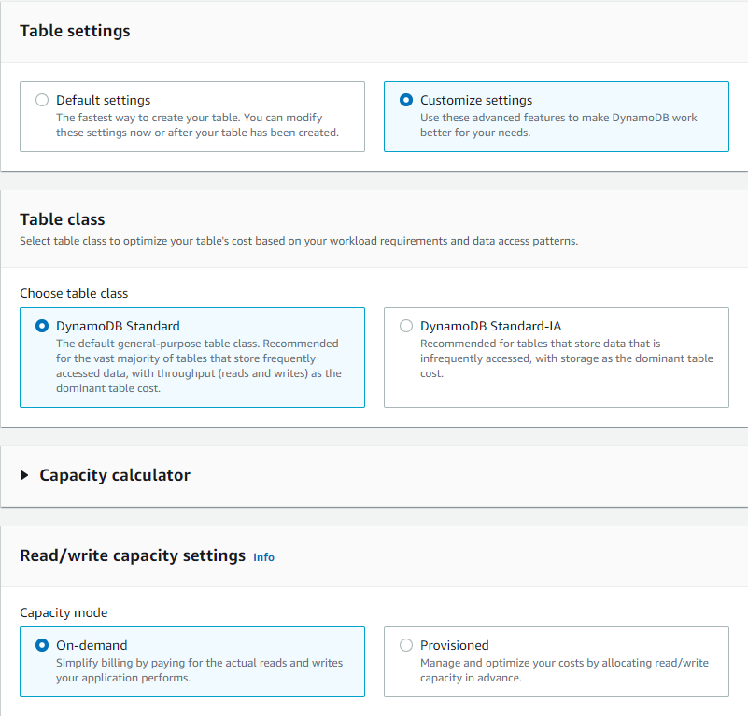

S3

Region: Global
RESTRICTED TO:
Bucket name: awsnodejstraining

Instruction: Do not create any bucket, just use your group’s folder

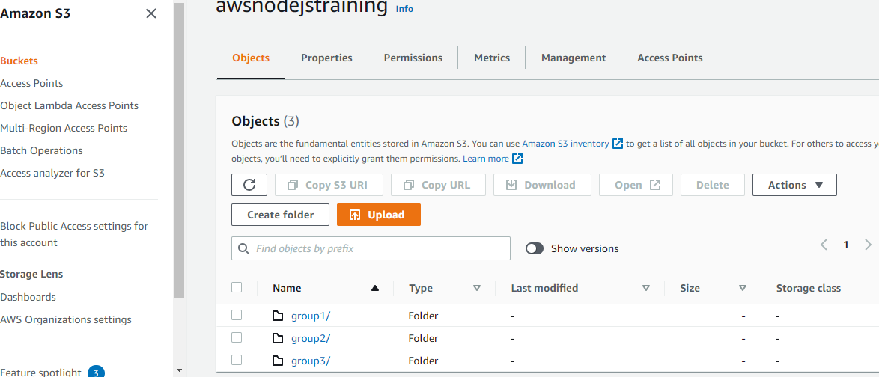

API GATEWAY

RESTRICTED TO:
Region: ap-southeast-1(Singapore)

To enable cloudwatch logs

Step 1. Use this Role ARN: arn:aws:iam::702954692849:role/awsnodetraining-dev-api-logs-role

Step 2.
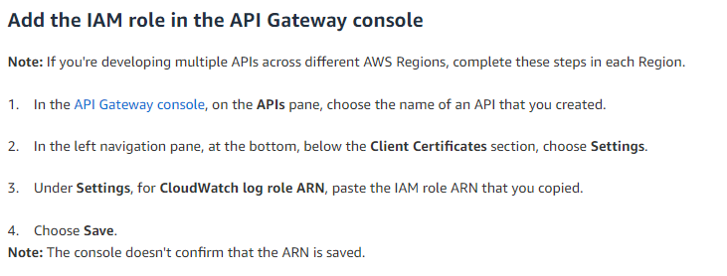
Reference: https://aws.amazon.com/premiumsupport/knowledge-center/api-gateway-cloudwatch-logs/

